05_ERD Diagrams
Created by Group1 : Rifat Mahmood Khadim: G1432255 & Saima Ijaz: G1432248

Crownfield Eye Hospital conceptual ERD

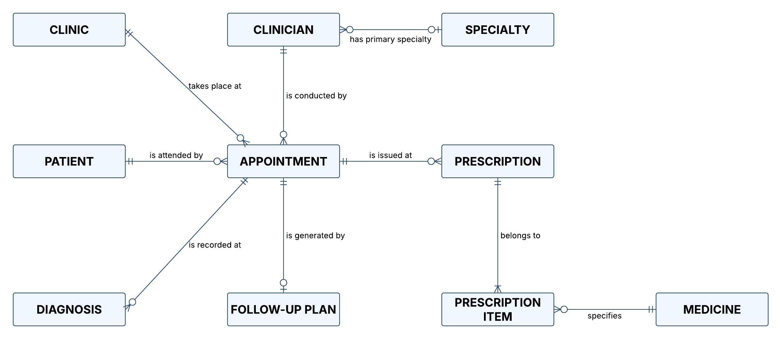
Figure 1. Crownfield Eye Hospital conceptual ERD, exported from the original Lucidchart diagram.

Logical entity relationship diagram

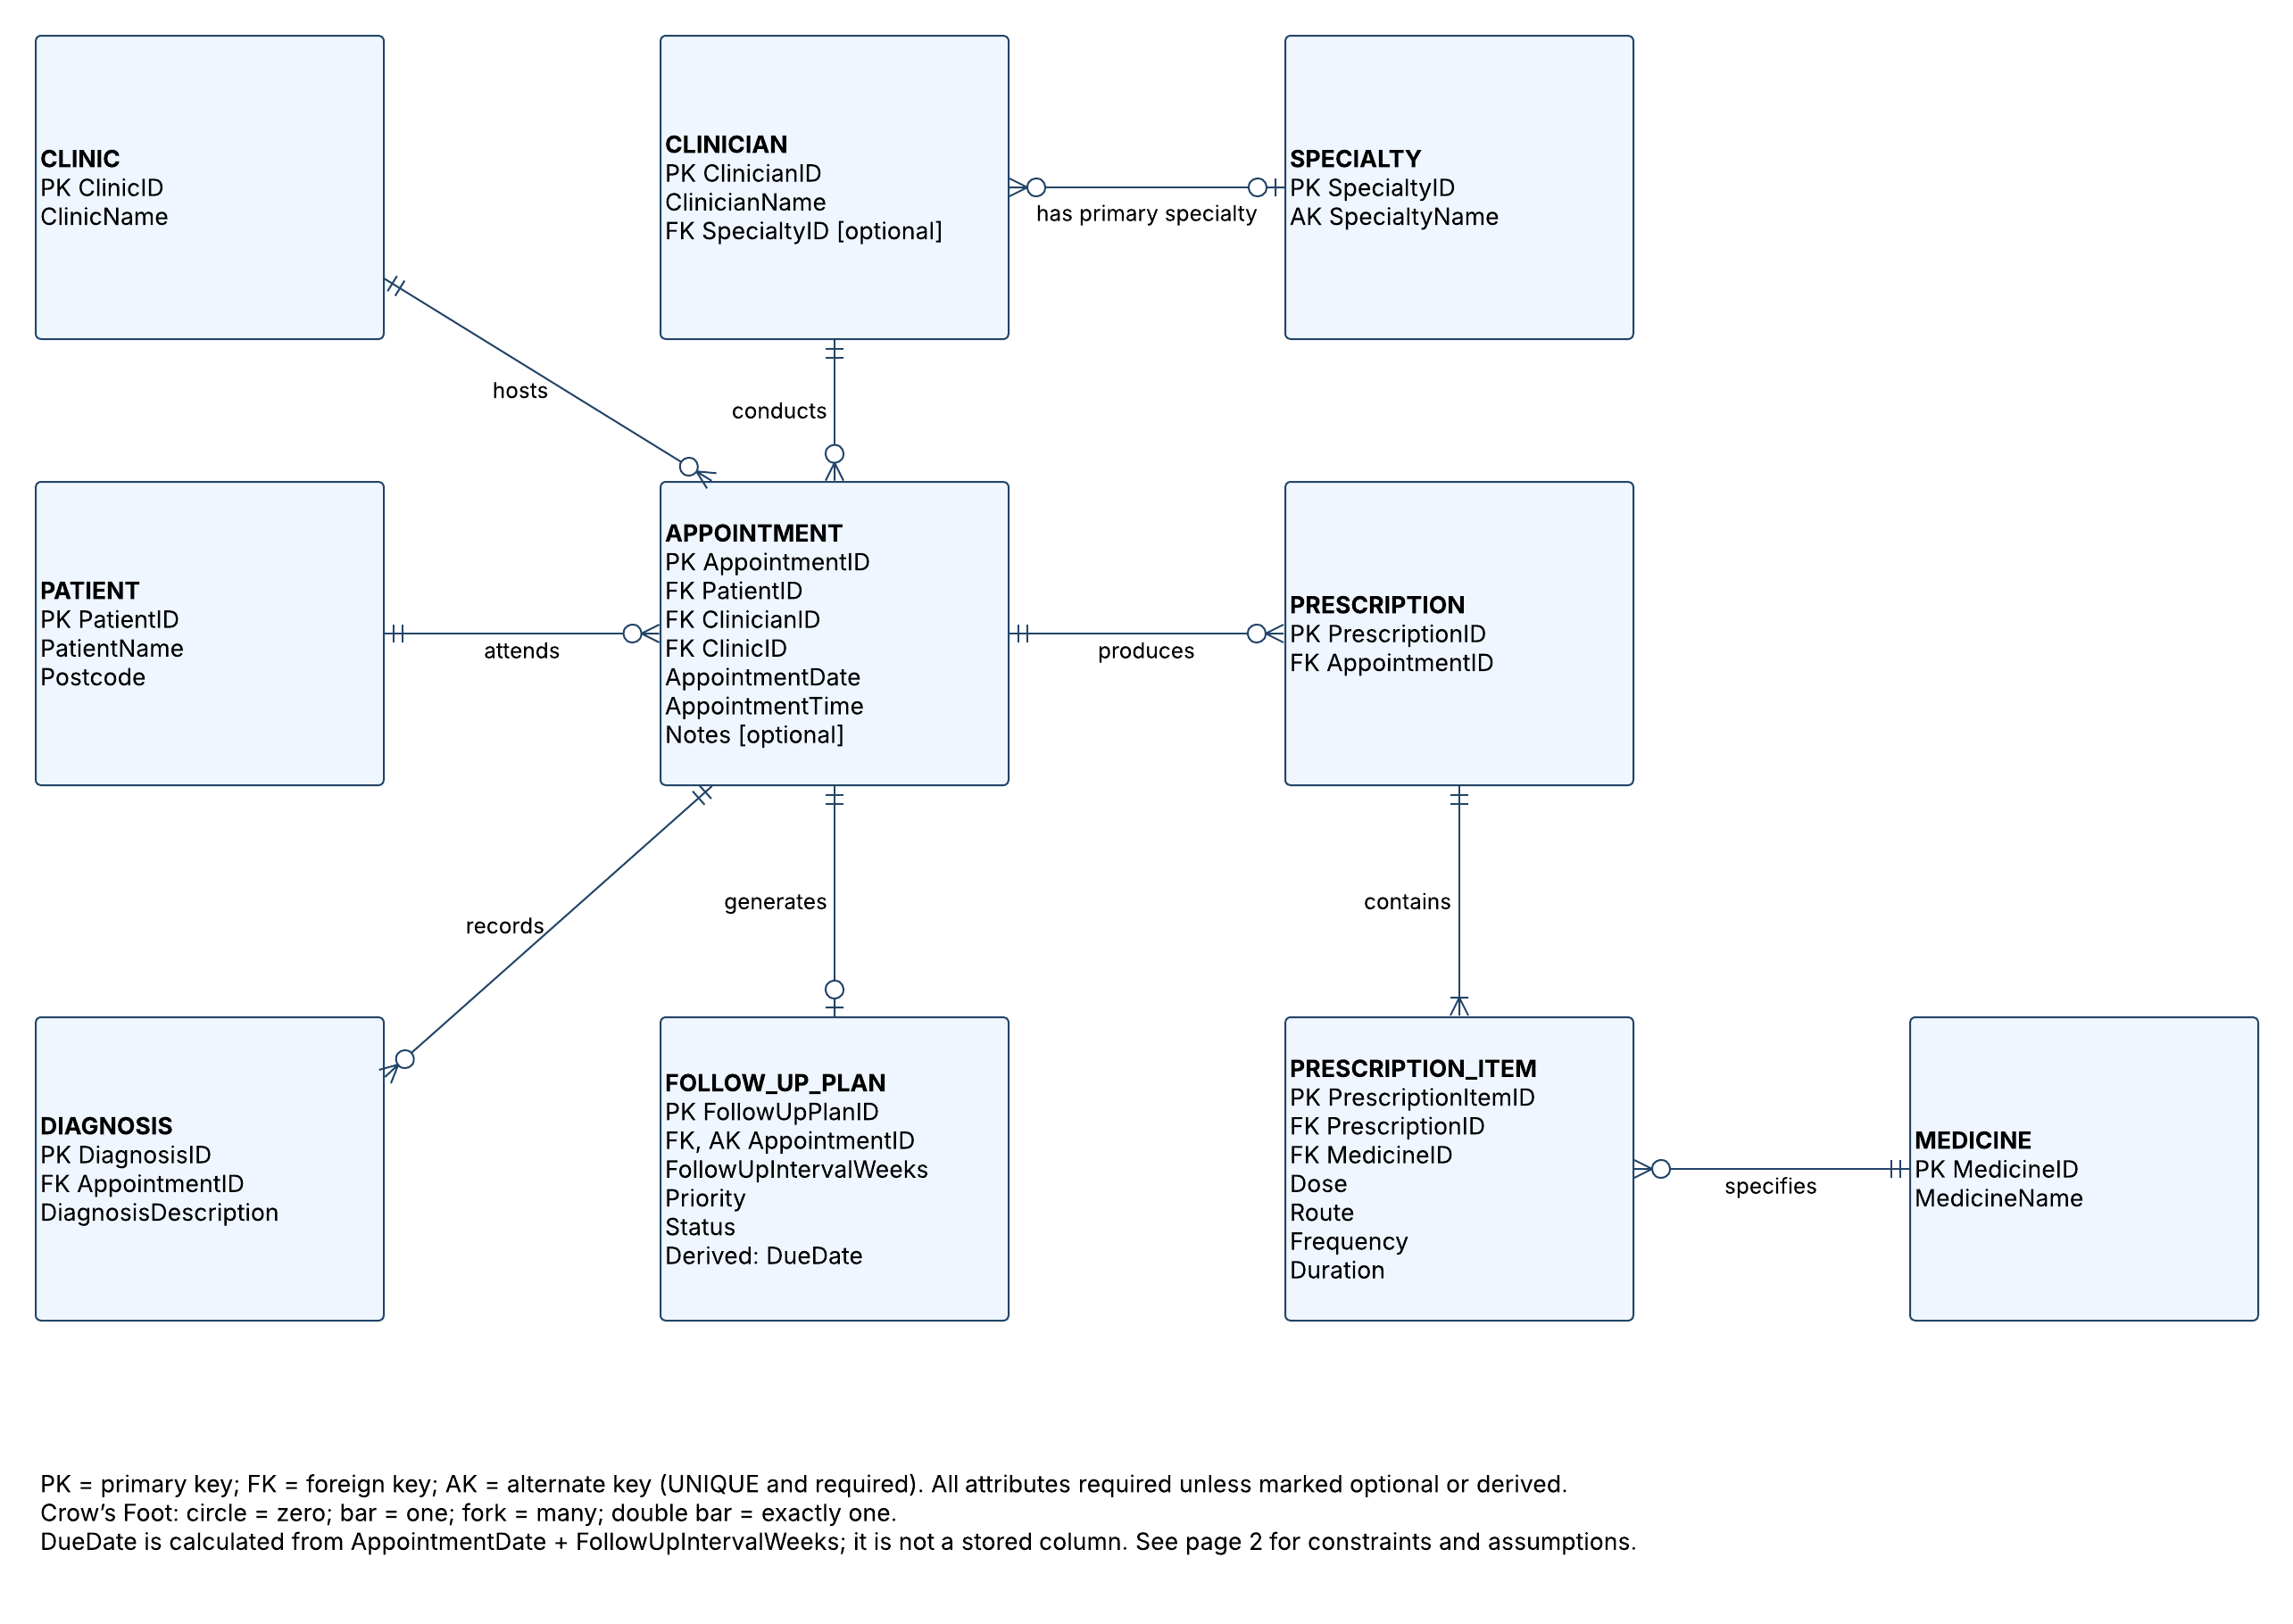

Figure 2. Original logical ERD showing attributes, keys and relationships (Crownfield project group, n.d.a).

Physical entity relationship diagram

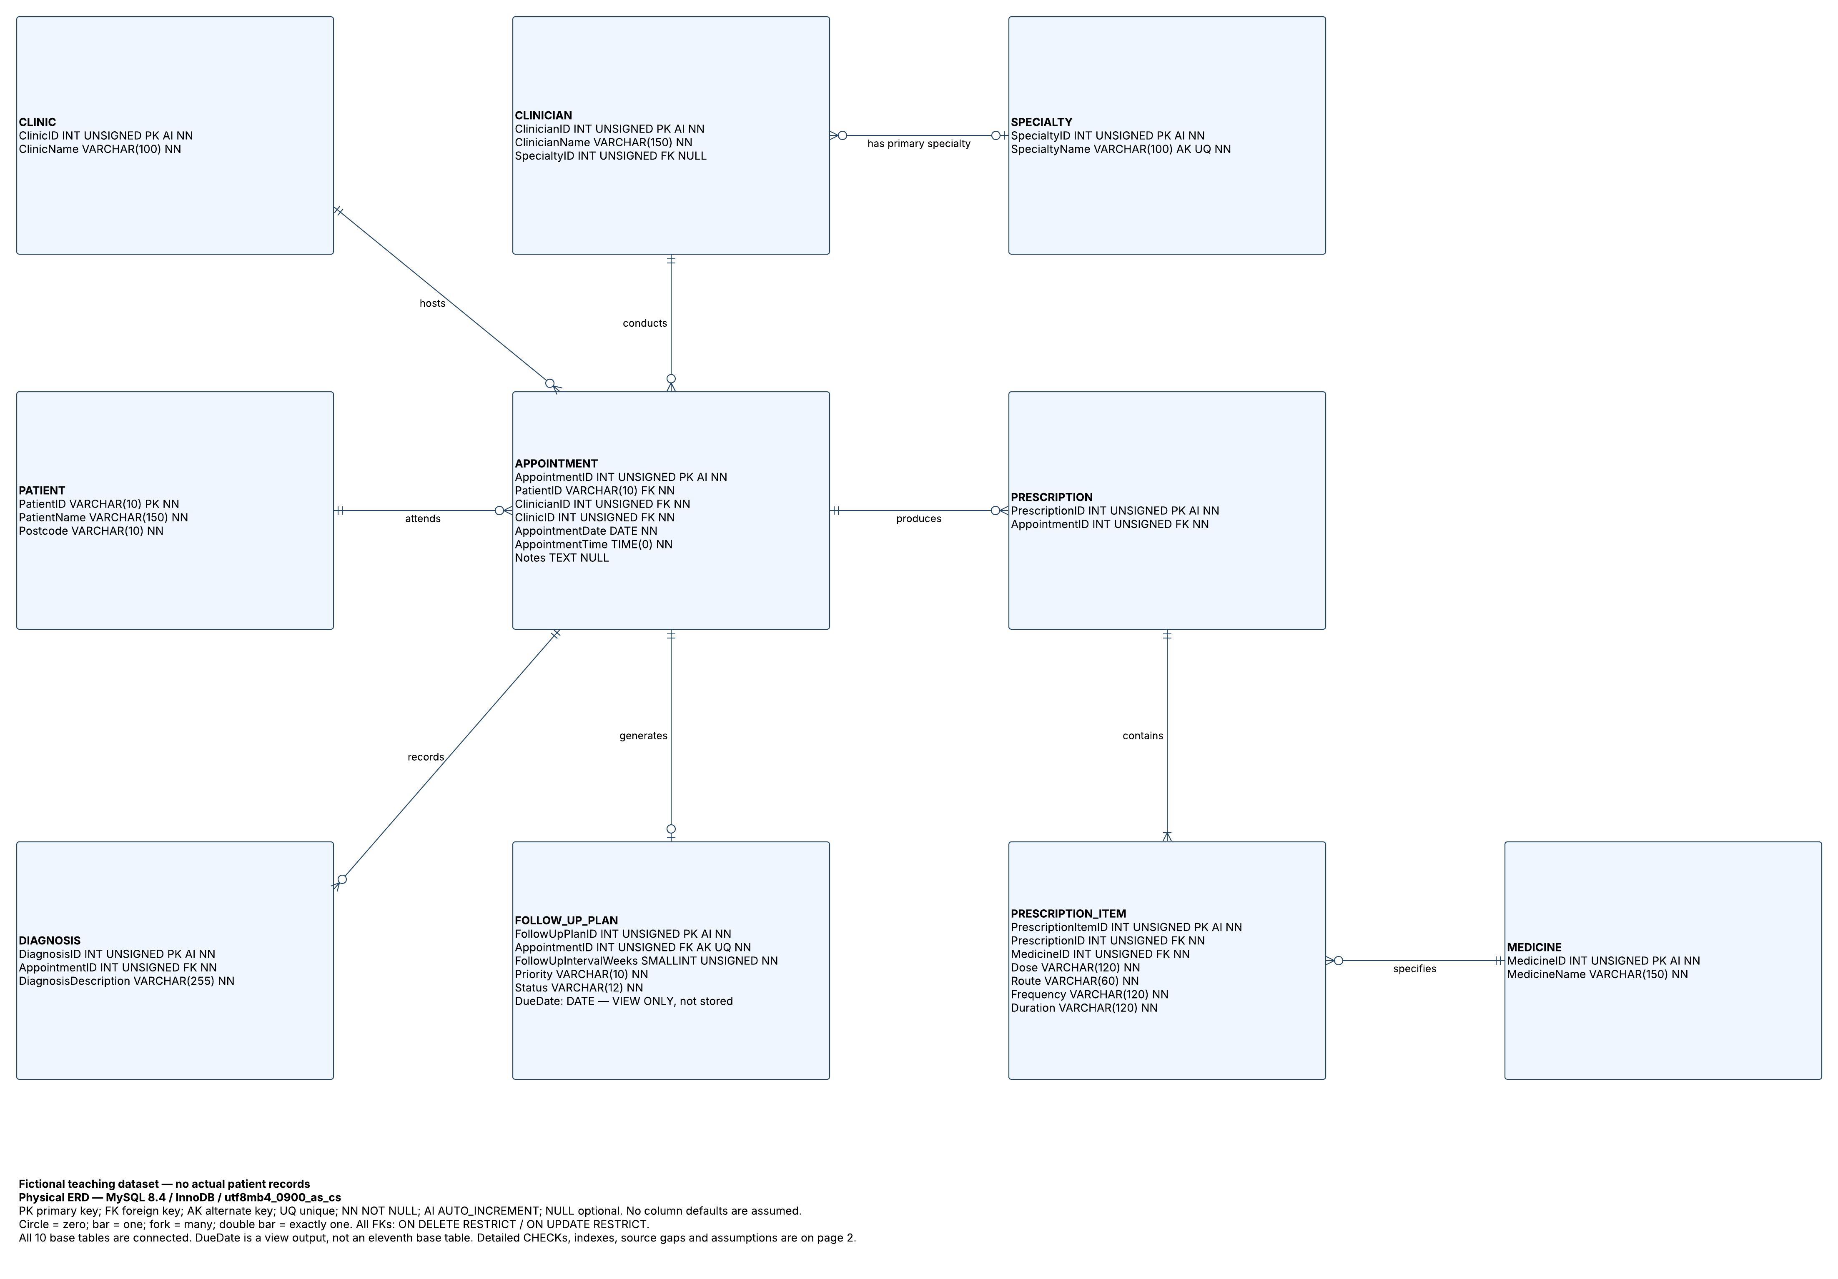

Figure 3. Original MySQL physical ERD showing data types, required fields and foreign keys (Crownfield project group, n.d.b).

Appendix

All these diagrams are created by Lucid Chart

